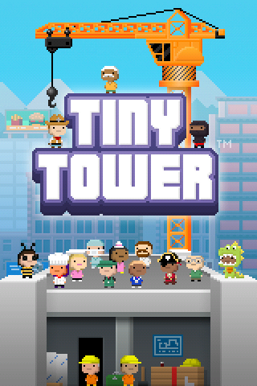
Tiny tower experience part 1
iOS experience
By: Sean Myrick
experience from:
2012 to 2015
part of a series on:
childhood nostalgia
game by:
NimbleBit
Rating:
5.0/5.0
OS used: iOS 6.0
for the continued experience in 2019, try the daily articles starting from May 10th 2019 and on (up to [not yet canceled])
^{document version: 3}
📖 Table of contents 📖
1. start
2. the inappropriate message
3. reset
4. enjoying the upgrades
5. playing around
6. Attempted Android upgrade
7. Thoughts (2019)

subjects:
Start
The inappropriate message
reset
enjoying the upgrades
playing around
Attempted Android upgrade
Thoughts (2019)

Start:
When I received my iPod, it came with many games installed on it by my family. One of them was Tiny tower. This came to be one of my favorite mobile games. Tiny tower is a tower building game by the Mobile Game company, NimbleBit.

The inappropriate message
So in Tiny Tower, there is this built-in social media for your bitizens called BitBook. It is a parody of FaceBook. You are not able to really post here, but you can share the auto-generated content your bitizens post. One day, in a car ride, I was playing Tiny Tower. I was messing around. I made a Bitizen in a chicken suit say “I’m a fucking turkey” and I tried to share it to my device. What I didn’t realize is that it shared it to all of my dad’s friends. When we got home, he was really mad about it, and he said that he lost a lot of friends because of it. I didn’t even know that his account was connected to the game. I got yelled at, and that is it.

Reset
I went through summer daycare programs a lot while growing up. I got special permission to have an electronic device with me, as it made it easier for me to get away when bad things happened. One day on a field trip, the game glitched out really bad. It got completely stuck, and there was no way to keep playing. So unfortunately, I had to reset my 48 floor tower. At the time, I didn’t have a bad reaction to it, and I was quickly able to restart the tower (these days, that isn’t possible, there would be issues with it first) it did this during a bus ride. I got nothing but the reset except for a functional game. That meant everything had to be started over.

Enjoying the upgrades
Tiny tower is a very enjoyable game. When I used to play games when I was younger, I imagined that what I was doing was creating a new world. Tiny Tower was one of those games where this happened. I would enjoy looking at the textures of the elevator, and the ground, repainting the rooms felt nice, and doing upgrades felt good. I was trying to make my tower reach space. During my iOS experience of this game, that never happened though.

Playing around
I commonly joked around while playing Tiny Tower. Sometimes, there would be a character that came in an elevator with all green hair, on his beard and his head. I would joke around and pretend that he was throwing up because the elevator was going too fast. The mouths of the Tiny Tower bitizens reminded me of my black Moore Goldfish.

Attempted Android upgrade
When I got my first Android phoned (sharing with my dad, it was his old Samsung Galaxy SII) I tried to install Tiny Tower again. It required some sign-in option that didn’t really seem legit. I don’t think it was Google related. I skipped over it, and 4 years later, I met the game again.

Thoughts (2019)
When I reinstalled the game on May 10th 2019, I noticed that a lot of the game had changed. There is also a form now where they ask the important of features like costumes, upgrades, and customizations. I really hope something doesn’t go wrong and they wipe everything. The game is completely different now. There is an additional soundtrack, the way of upgrades changed, there is a tutorial now, you unlock costumes differently, there are different elevators, the way upgrading an elevator changed, now you have to upgrade a motor separately to get it to go faster. I am working on recovering my old iOS account and all the games, then finding an iOS 6 emulator so that I can play these games again, and make archives. For now, I am working off the Android 7 version. The game has changed a lot, but it is still fun. It is a lot easier to earn Bux, there is a raffle, there are lots of new elevators, lobbies, and roofs. You originally weren’t able to really do much to the lobby or the roof there are so many other new features.

I came up with this idea: in the NimbleBit universe, this is what atoms look like
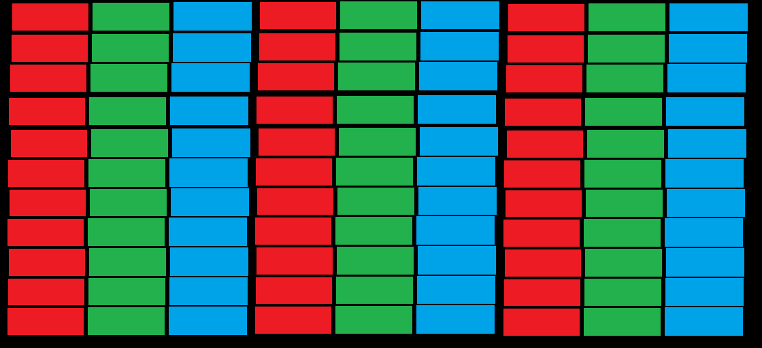
Joke explaining time for people who don’t get it: if you actually see a pixel on your screen, they are just red, green and blue lights. I had to redraw an image, as I lost the original file. If I ever find it again, it will go here:
[placeholder]

concerning poll
When I rejoined Tiny Tower back in 2019, I found a concerning poll:
Tower Customization Poll
Putting our finger on the pulse of important Tiny Tower issues! Your responses are anonymous!
* Required
How important is DRESSING UP your BITIZENS? *
Not important, I never use this feature.
Somewhat important, but I could live without this feature.
Important. I enjoy using this feature.
Crucial! I'd stop playing without this feature!
Let me explain why! (optional)
How important is RENAMING your BITIZENS? *
Not important, I never use this feature.
Somewhat important, but I could live without this feature.
Important. I enjoy using this feature.
Crucial! I'd stop playing without this feature!
Let me explain why! (optional)
How important is REPAINTING your FLOORS? *
Not important, I never use this feature.
Somewhat important, but I could live without this feature.
Important. I enjoy using this feature.
Crucial! I'd stop playing without this feature!
Let me explain why! (optional)
How important is RENAMING your FLOORS? *
Not important, I never use this feature.
Somewhat important, but I could live without this feature.
Important. I enjoy using this feature.
Crucial! I'd stop playing without this feature!
Let me explain why! (optional)
How important is SWAPPING your ROOF/LOBBY/ELEVATOR? *
Not important, I never use this feature.
Somewhat important, but I could live without this feature.
Important. I enjoy using this feature.
Crucial! I'd stop playing without this feature!
Let me explain why! (optional)
Never submit passwords through Google Forms.
This content is neither created nor endorsed by Google. Report Abuse - Terms of Service
Forms

form ripped from https://docs.google.com/forms/d/e/1FAIpQLSeZI0mNvyXqO9PHCQ7O6HX49t1WJ2V4RsoWfdTq6O6pz083XQ/viewform?usp=send_form
I don’t want these features to go away. They are all parts of the game that I greatly enjoy.

Bugs
there are some annoying bugs in the game and some broken features
* the elevator can randomly go up or down several floors on its own. This is either motion control issues (not it) or a bug (that’s it)
* when attempting to share pictures from bitbook, the pictures get distorted. Here are 2 examples from May 15th 2019:
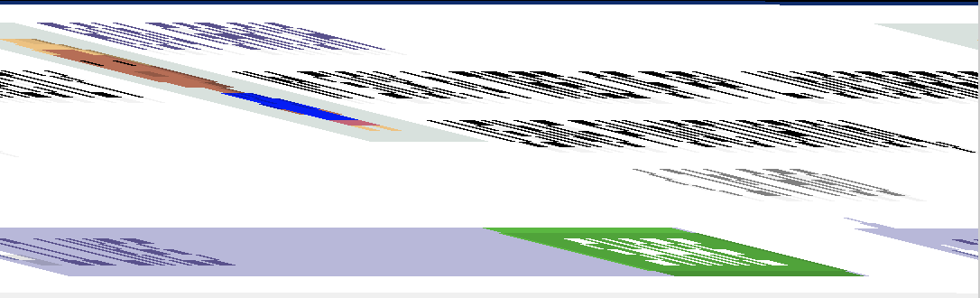
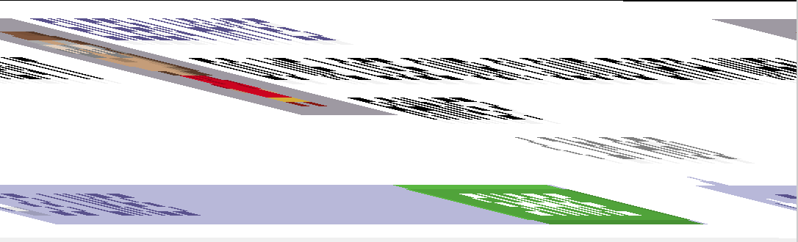
it is nearly impossible to make out what is being said.
* more bugs soon to be reported here

To be continued...

